**Department of Industry (DOI)**

* **Application for FDI Project Registration and Final Approval.**
* **Application for Domestic Project Approval**

**Electronic Government to Citizen Service Delivery System- Enhancement**

**Submitted By:**



**NGN Technologies Ltd**

**Software Requirement Specification**



|  |  |  |
| --- | --- | --- |
| **DOCUMENT RELEASE NOTICE** | | |
| **Document Title** | **:** | **Electronic Government to Citizen Service Delivery System- Upgradation** |
| **Release (Number)** | : |  |
| **Date of Release** | : |  |
| **Department** | : | Department of Industry (DOI) |
| **Process Owner(s)** | : |  |
| **Author(s) / Date** | : | Tshewang Tenzin |
| **Reviewer(s) / Date** | : | Khemlal Chhetri /Tshewang Tenzin |
| **Approved by / Date** | : |  |

|  |  |  |  |
| --- | --- | --- | --- |
| Document Acceptance | | | |
| **Process Owner** | **Designation** | **Agency** | **Sign Off** |
| Mr. Tandin Tshering | Director | Department of Industry |  |
| Mr. Sonam Tshokey | Industries Officer | Foreign Direct Investment Division, DOI |  |
| Mr. Ugyen Tenzin | Trade Officer | Regional Trade and Industry Officer, Thimphu |  |
| Mr. Sonam Chedup | Head, ICT | MoEA |  |

Table of Contents

1 Introduction 5

1.1 Purpose 5

1.2 Scope 5

1.3 Glossary 6

1.4 References 6

2 Service Specification 7

2.1 Process Flow for application for FDI Project Registration & Final Approval. 7

2.1.1 Transaction Volume 9

2.1.2 Use-Case# 1: Submission of FDI Registration Application Form (FDIRAF) 9

2.1.3 Use-Case#2: Verification of FDIRA and generation of FDIRC by Designated Person from FDI division, DOI 13

2.1.4 Use-Case#3: Preparation of Business plan and submission of application for business plan. 19

2.1.5 Use-Case#4: Verification of FDI business plan application by Designated Person from FDI division, DOI 25

2.2 Process Flow for application for Domestic Project Approval. 30

2.2.1 Transaction Volume 31

2.2.2 Use-Case# 1: Submission of Domestic Project Approval Application 32

2.2.3 Use-Case#2: Verification of application and generation of certificate by Designated Person from IID division, DOI 36

2.2.4 Use-Case#3: Preparation of Business plan and submission of application for business plan. 40

2.2.5 Use-Case#4: Verification of business plan application by Designated Person from IDD division, DOI 45

3 Reports 49

3.1 Report# 1: Detail Report for approved FDI Projects in a period 49

3.1.1 Type of Report 49

3.1.2 Purpose 49

3.1.3 Frequency 49

3.1.4 Access Control/Security 49

3.1.5 Date Fields 49

3.1.6 Search criteria/Input Parameters 49

# Introduction

The Department of Industry, Ministry of Economic Affairs, Royal Government of Bhutan, hereby referred to as DOI, intends to undertake upgradation of existing system built under the G2C phase II. The existing services automation was done in order to achieve an overall improvement in service delivery and other business satisfaction. With the above objective, DOI has endeavored to implement an online service delivery system which will serve as a unified platform for businessmen for availing services and DOI officials for delivering the same with a significant reduction in turn-around time and businessmen‘s inconvenience.

This document describes the detailed work-flow structure of FDI Registration and Domestic Project Registration under DOI. This describes the detailed process flow, accountable actors, envisaged benefits and screen captures from the indicative prototype. This document will serve as the main contention for developing the online service delivery framework for the said agency and will form the basis on which the actual system will be designed and implemented.

## Purpose

This Software Requirement Specification provides the design details for the existing system and the TO-BE system, which is to be developed for Department of Industry.

It will explain the process of each service delivery work-flow, features of the system and the interfaces of the system. This document is intended for both the stakeholders and the developers of the system.

This will also serve as a reference document for the maintenance team who will be responsible for the maintenance of the system after the final release of the product.

## Scope

This document contains the complete description of design for application for DFI project registration & final approval and application for domestic project approval under Department of Industry.This assignment is to upgrade, design, develop and deploy web-based Service Delivery system for Department of Industry.

## Glossary

|  |  |
| --- | --- |
| SRS | Software Requirement Specification |
| DoI | Department of Industry |
| G2C | Government to Citizen |
| ICT | Information Communication Technology |
| UAT | User Acceptance Test |
| FDIRA | Foreign Direct Investment Registration Application |

## References

* Existing Software Requirement Specifications documents
* Brainstorming session held during the System study period
* Documents supplied by G2C during the course of requirement study
* Request for Proposal document

# Service Specification

## Process Flow.

***2.1.1 Application for FDI Project Registration & Final Approval***

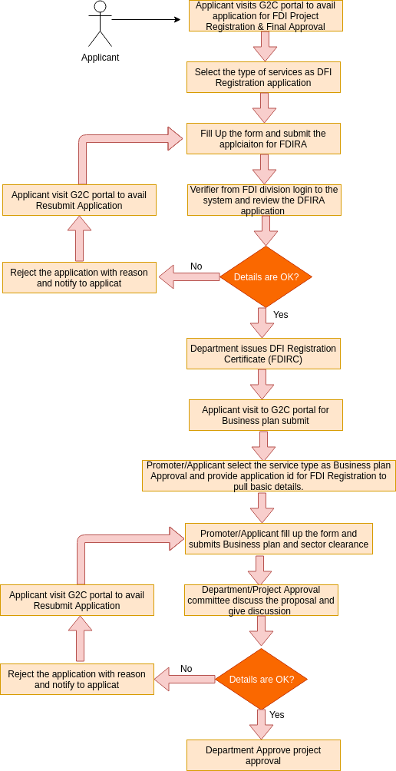

* The process flow shown above depicts the Application for FDI Project Registration & Final Approval. It has mainly four use-cases that includes

1. Submission of FDI Registration Application Form (FDIRAF),
2. Verification of FDIRA and generation of FDIRC by designated person from FDI Division of DoI ,
3. Submission of Business plan.
4. Verification and approval of business plan.

* Functionality wise there will be the following parts:
* Apply for the **Application of DFI Project Registration & Final Approval** under DOI will be made open to public where promoters/applicant at any time.
* Check the status of application- is exposed to the Common G2C Service Gateway.
* Verification of FDIRA and generation of FDI Registration Certificate by the designated person form FDI division or reject the application with proper reasons to resubmit the application.
* Apply for the Business plan from same link **(Application of DFI Project Registration & Final Approval)** which is open to pubic where promoters/applicant can apply at any time or resubmit the application if its rejected according to the remarks or reason mentioned for rejection.
* Designated person form DFI can verify the business plan and generate final certificate and again reject with proper reason if application details does not meets the application requirements/mandates.
* Applicant/promoters can collect the final business plan certificate to avail license application if this application is approved or resubmit the application according to the reason mentioned with the application if the application is rejected.

### Transaction Volume

The estimated number of application for Project Approval for Medium and Large Industries per year is around 15 to 20.

***2.1.2 Application for Domestic Project Approval***

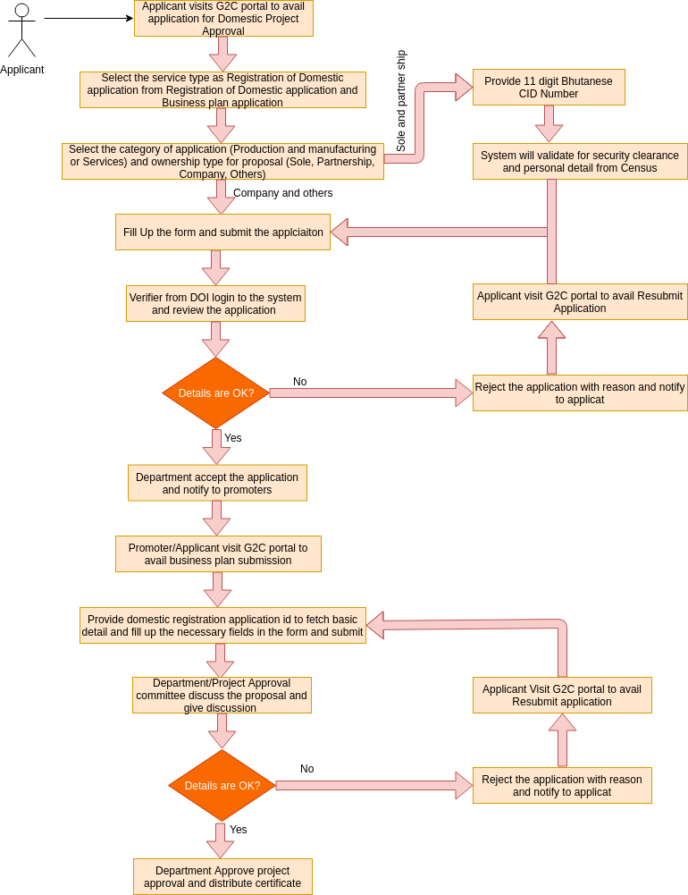

* The process flow shown above depicts the Application for Domestic Project Registration. It has mainly four use-cases that includes

1. Submission of Domestic Registration Application Form,
2. Verification of Application and generation of certificate by designated person from IID Division of DOI ,
3. Submission of Business plan.
4. Verification and approval of business plan.

* Functionality wise there will be the following parts:
* Apply for the **Application for Domestic Project Registration** under DOI will be made open to public where promoters/applicant can apply at any time.
* Check the status of application- is exposed to the Common G2C Service Gateway.
* Verification of Application and generation of Certificate by the designated person form IID division or reject the application with proper reasons to resubmit the application.
* Apply for the Business plan from same link **(Application For Domestic Project Registration)** after selecting business plan as service type which is open to pubic where promoters/applicant can apply at any time or resubmit the application if its rejected according to the remarks or reason mentioned for rejection.
* Designated person form IID can verify the business plan and generate final certificate and again reject with proper reason if application details does not meets the application requirements/mandates.
* Applicant/promoters can collect the final business plan certificate to avail license application if this application is approved or resubmit the application according to the reason mentioned with the application if the application is rejected.

### Transaction Volume

The estimated number of application for Project Approval for Medium and Large Industries per year is around 15 to 20.

***2.1.3 Application for Industry License***

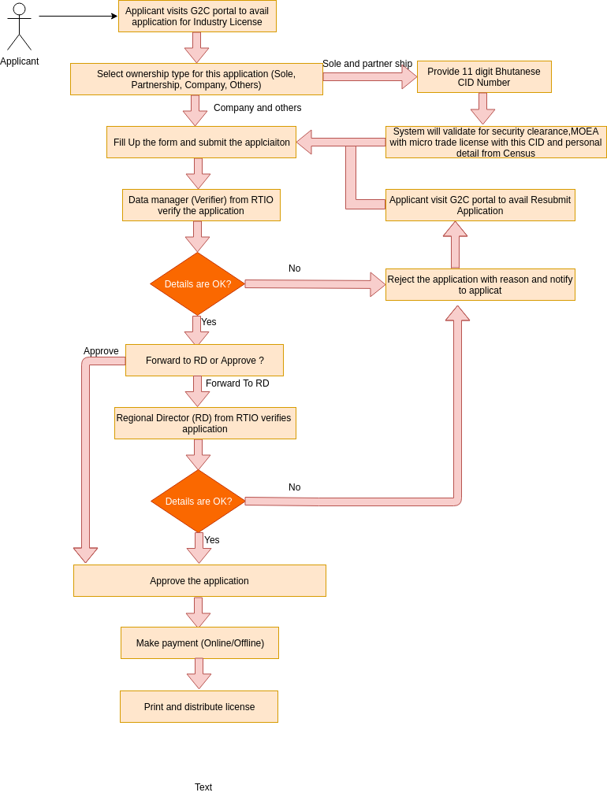

* The process flow shown above depicts the Application for Industry license. It has mainly five use-cases that includes

1. Submission of Application,
2. Verification or approval of application by DM ,
3. Approval of application by RD.
4. Payment update by applicant(online) or accounts(offline/cash).
5. Print and distribute license.

* Functionality wise there will be the following parts:
* Apply for the **Application for Domestic Project Registration** under DOI will be made open to public where promoters/applicant can apply at any time.
* Check the status of application- is exposed to the Common G2C Service Gateway.
* Verification of Application and generation of Certificate by the designated person form IID division or reject the application with proper reasons to resubmit the application.
* Apply for the Business plan from same link **(Application For Domestic Project Registration)** after selecting business plan as service type which is open to pubic where promoters/applicant can apply at any time or resubmit the application if its rejected according to the remarks or reason mentioned for rejection.
* Designated person form IID can verify the business plan and generate final certificate and again reject with proper reason if application details does not meets the application requirements/mandates.
* Applicant/promoters can collect the final business plan certificate to avail license application if this application is approved or resubmit the application according to the reason mentioned with the application if the application is rejected.

### Transaction Volume

The estimated number of application for Project Approval for Medium and Large Industries per year is around 15 to 20.

### Use-Case# 1: Submission of FDI Registration Application Form (FDIRAF)

#### Brief Description

This Use Case is how the promoter fills up the FDIRA required for Project Approval and submits the same to FDI division under DoI.

#### Frequency

As mentioned earlier, the number of FDIRA applications is expected to be 15 to 20 per year.

#### Actor(s)

The actors for this use case are the Promoters who are applying for Project Approval.

#### Basic Flow of Events

* Applicant fills up the FDIRA form
* Submits the FDIRA from
* The Application status should be Waiting for FDI Approval (FDIRA)

#### Alternative Flows

N.A.

#### Special Requirements

N.A.

#### Pre-conditions

Applicant needs to have internet access and know the url to enter into the system.

#### Post-conditions

Designated person from FDI gets the submitted FDIRA in his/her task list.

#### Trigger

This process starts after clicking on the Application for FDI Project Registration & Final Approval link from portal.

#### User Interface Presentation

* Visit G2C portal to avail Application for FDI Project Registration & Final Approval under Industry Services.

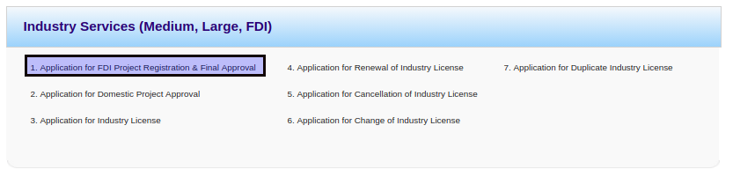

* Select service type as DFI Registration application.

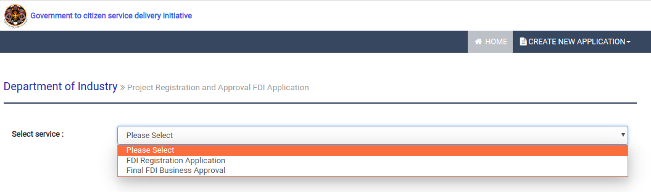

* Applicant will be redirected to the following DFI Registration form.

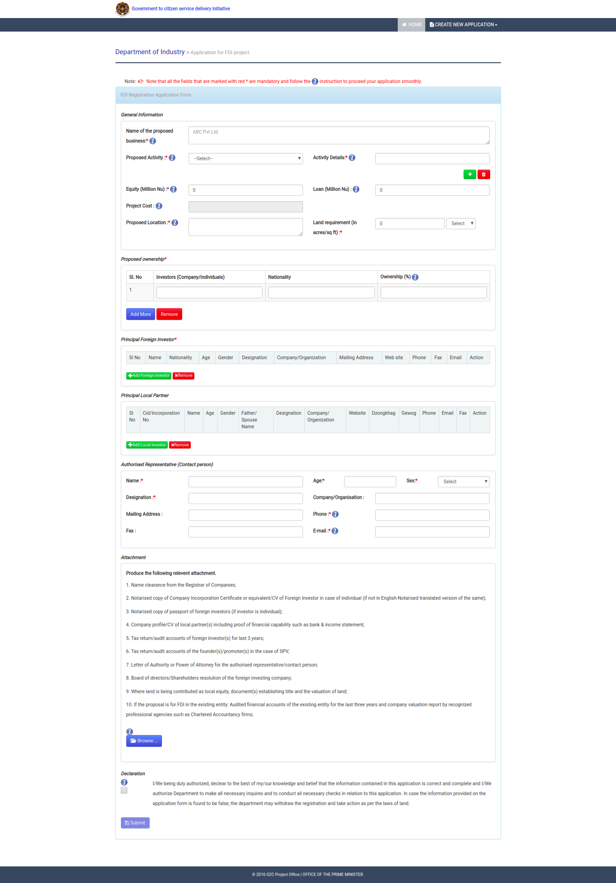

* The relevant scanned documents to be attached would be as follows:

1. Name clearance letter from the Registrar of Companies;
2. Notarised copy of Company Incorporation Certificate or equivalent/CV of Foreign Investor in case of individual (if not in English – Notarised translated version of the same)
3. Notarised copy of passport of foreign investors (if investor is individual);
4. Company Profile/CV of local partner(s) including proof of financial capability such as bank & income statement;
5. Tax return/audited accounts of foreign investor (s) for last 3 years;
6. Tax return/audited accounts of the founder(s)/promoter(s) in the case of SPV
7. Letter of Authority or Power of Attorney for the authorised representative/contact person;
8. Board of Directors’/Shareholders’ resolution of the foreign investing company
9. Where land is being contributed as local equity, document(s) establishing title and the valuation of land;
10. If the proposal is for FDI in an existing entity: Audited Final Accounts of the existing entity for the last three years and company valuation report by recognized professional agencies such as Chartered Accountancy firms.

After completing the form, the promoter can submit the form and will be redirected to following acknowledgement page

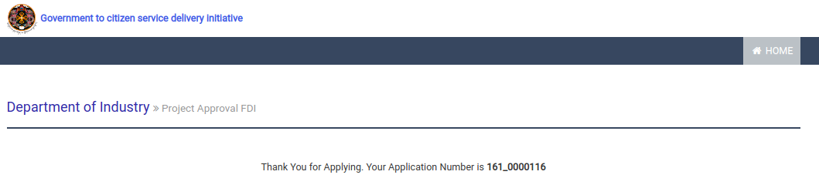

### Use-Case#2: Verification of FDIRA and generation of FDIRC by Designated Person from FDI division, DOI

#### Brief Description

This Use-Case is all about how the FDIRA is verified by the designated person from FDI. Also it talks about how the FDIRC is generated after the FDIRA gets approval.

#### Frequency

As mentioned earlier, the number of FDIRA applications is expected to be 15 to 20 per year.

#### Actor(s)

The acting member to perform this task will be the designated person from FDI.

#### Basic Flow of Events

* The designated person from FDI logs into the System and gets the task list.
* He/she verifies the details of the DFIRA.
* Approve the DFIRA with proper remarks.
* The application status should be updated to FDIRC issued.

#### Alternative Flows

If the designated person from FDI finds that the FDIRA can be rejected then he/she can do that with proper reasons for rejecting the application and accordingly the promoters will be notified through email and sms.

#### Special Requirements

N.A.

#### Pre-conditions

The designated person from FDI needs to have valid Log-in Ids & Passwords to access the system.

#### Post-conditions

**Basic Flow**

* The applicant gets a notification for the FDIRA Approval.
* The designated person form DFI division takes a printed of the FDIRC.
* Promotes collects the FDIRC from FDI division (manual process).

#### Trigger

He/she starts performing the above mentioned tasks.

#### User Interface Presentation

* The designated person form DFI login to the system from the following link.

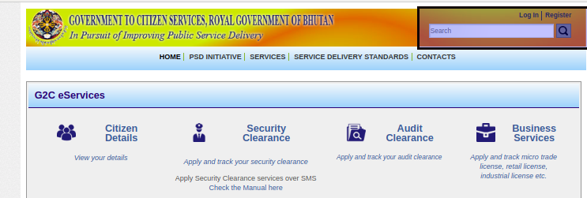

* He/she need to select application from group task and claim to my task by clicking on application number to verify the application. He/she can also release application back to group task by clicking on red cross image.

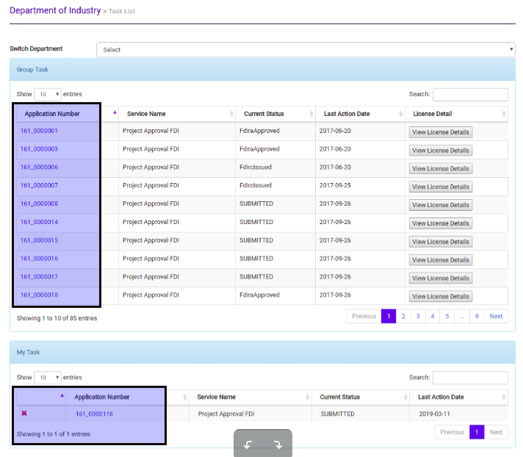

* Open the application from my task to verify and proceed further. The following form represent the application detail submitted by the promoters.

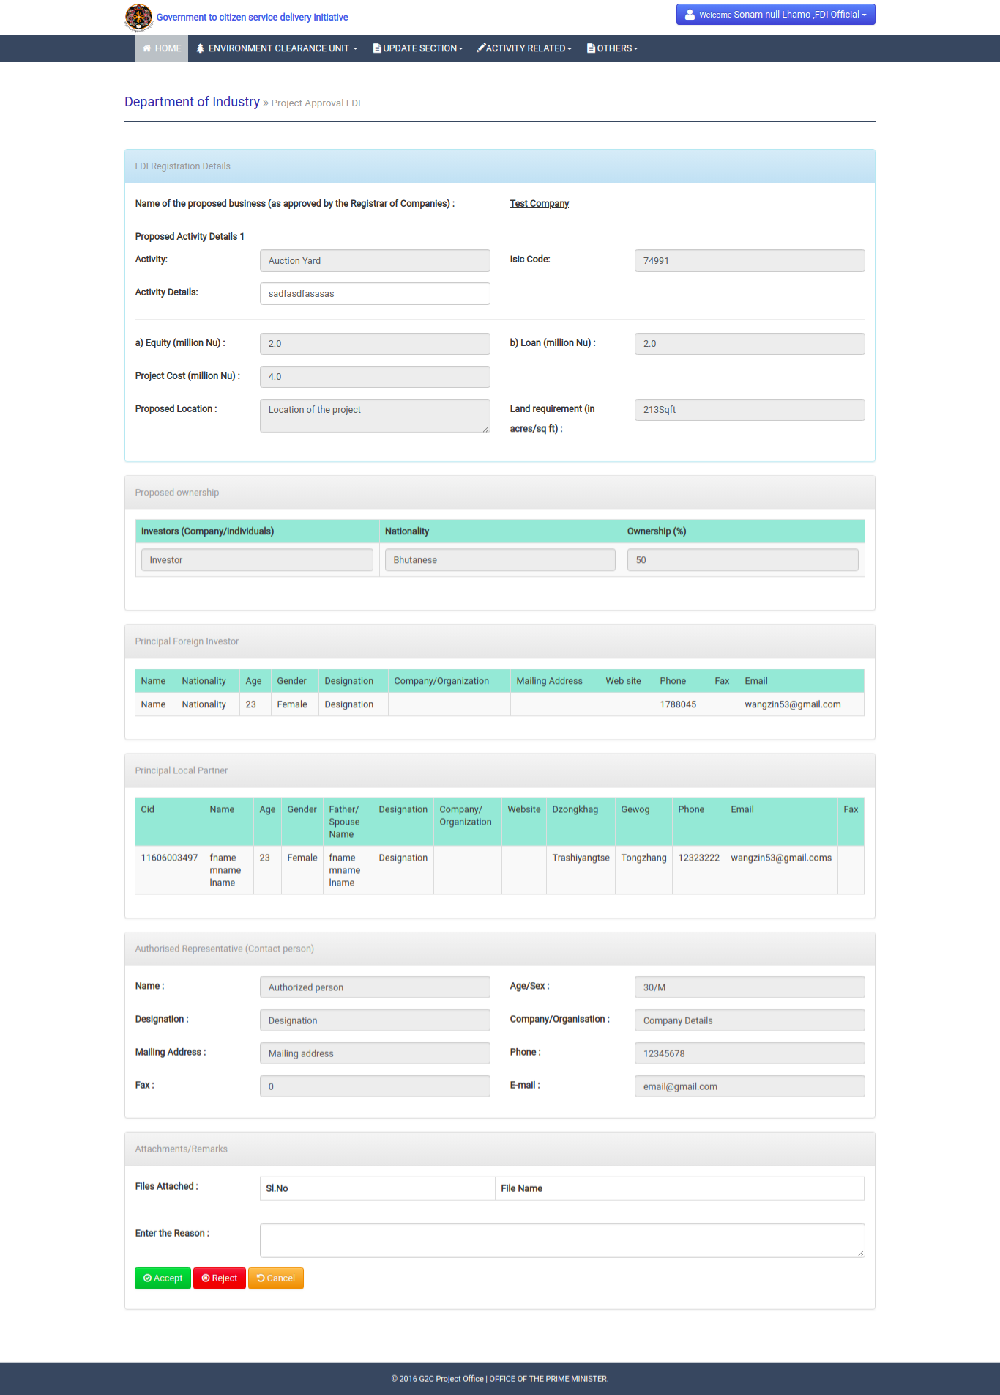

* After accepting the application, he/she needs to select relevant terms and condition on this application to produce certificates. He/she may added additional terms and condition if applicable and need to mention name of the concerned signatory person.

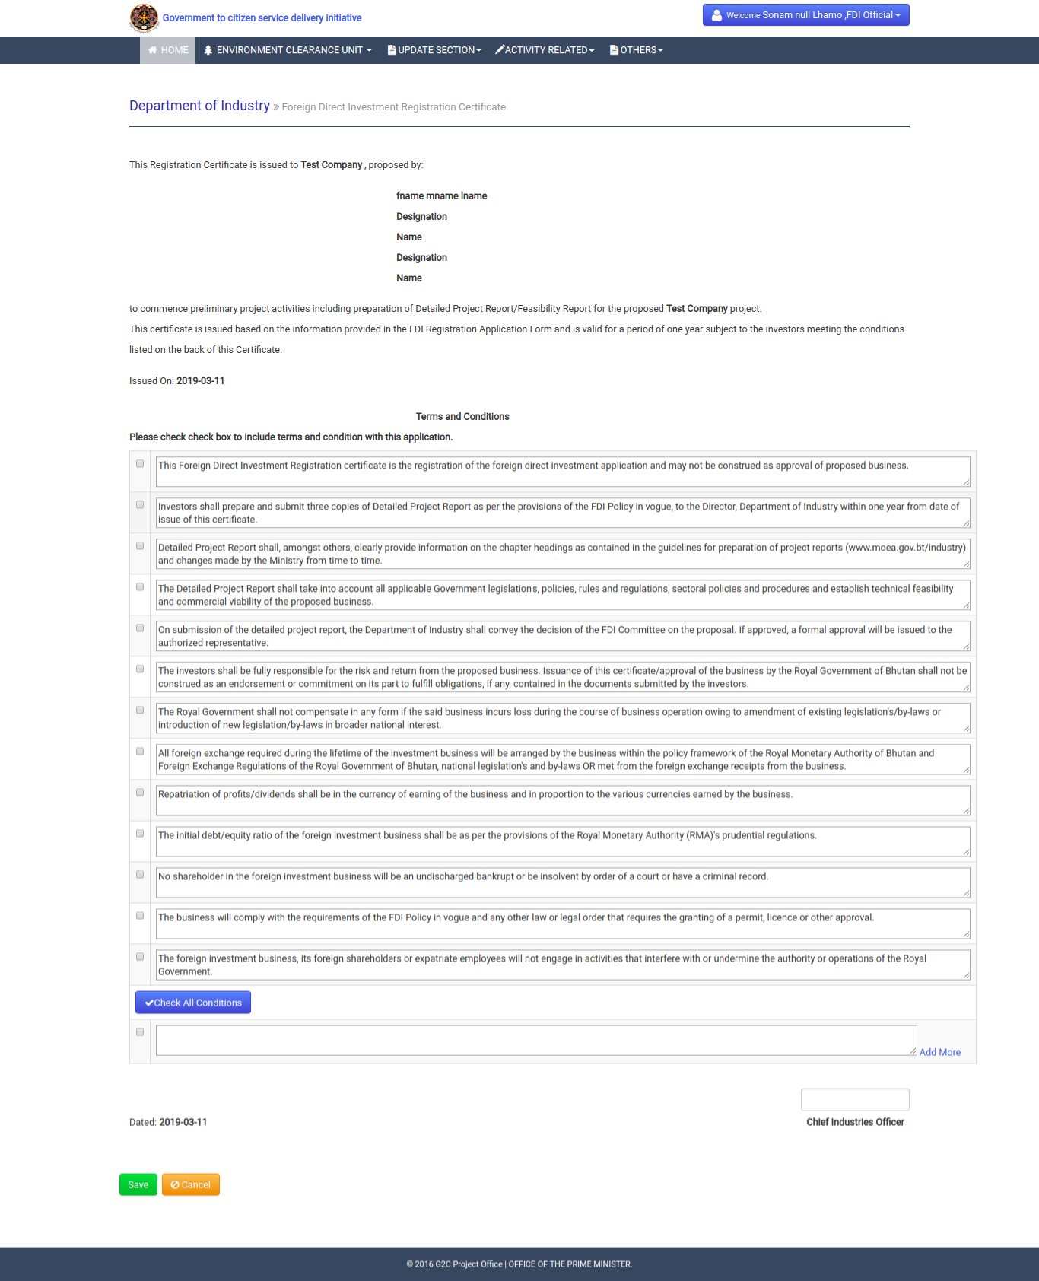

* Then he/she need to click on save button to generate certificate. Following image represent the certificate sample for promoters.

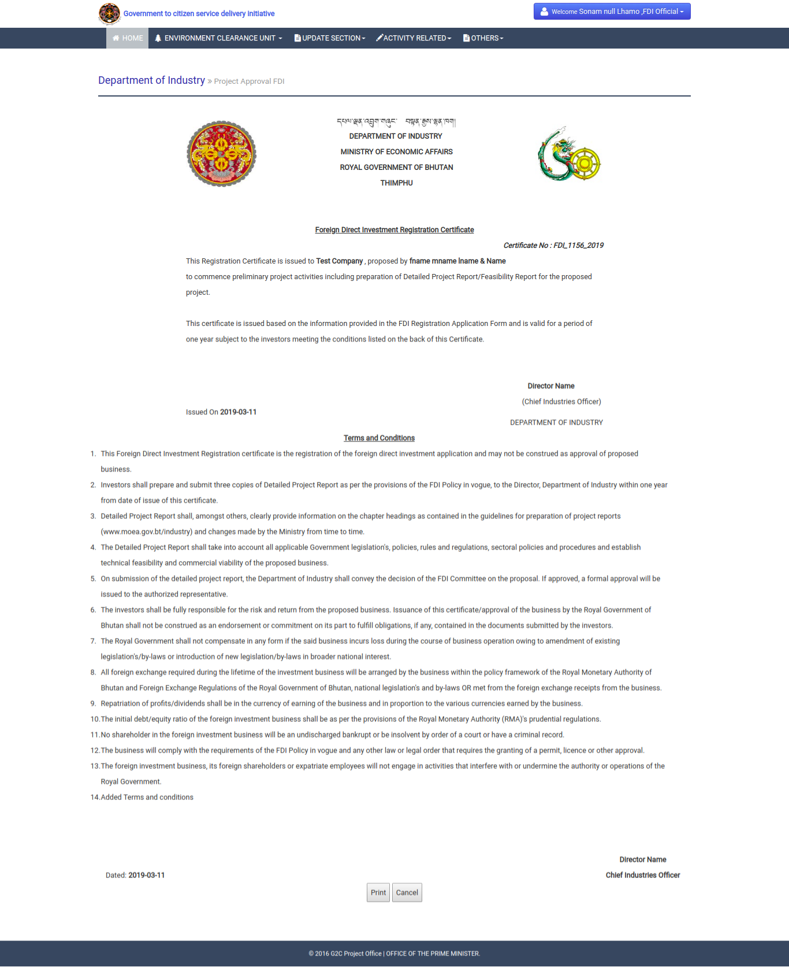

* After clicking on print button, the process completes and ready for the promoters to submit next business plan after taking this certificate form the focal person.

### Use-Case#3: Preparation of Business plan and submission of application for business plan.

#### Brief Description

This Use-Case is all about how the promoters prepare the business plan and submit the application.

#### Frequency

The number of Project Approval needed to be prepared is expected to be around 15 to 20.

#### Actor(s)

The acting member to perform this task will be the promoters /applicant.

#### Basic Flow of Events

* Applicant fills up the FDI Business form.
* Submits the FDI Business form.
* The application will be there at approval task of designated person from FDI.

#### Alternative Flows

N.A.

#### Special Requirements

N.A.

#### Pre-conditions

Applicant needs to have internet access and know the application Id of Application for DFI project Registration & final approval.

#### Post-conditions

Designated person from FDI gets the submitted FDI business plan applications in his/her task list.

#### Trigger

The process starts when the application for FDI project registration & final approval is approved by the designated person from FDI.

#### User Interface Presentation

* Visit G2C portal to avail Application for FDI Project Registration & Final Approval under Industry Services.



* Select service type as Final FDI Business approval.



* Applicant needs to provide the application Id of FDI Registration from the following interface.

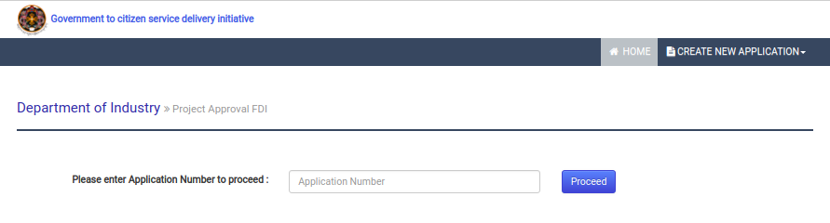

* After clicking on proceed button, if application id for FDI registration is valid and approved, then the promoter need to select which service the project is applicable for.

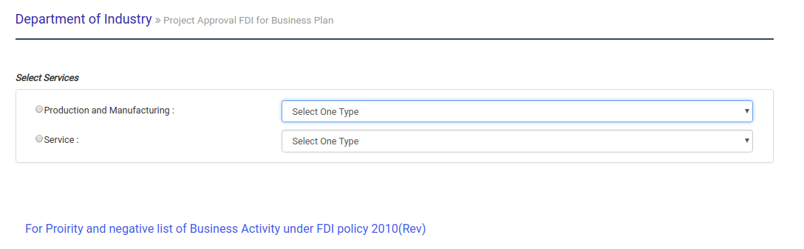

* On selecting the service, the form for Business plan will be displayed.

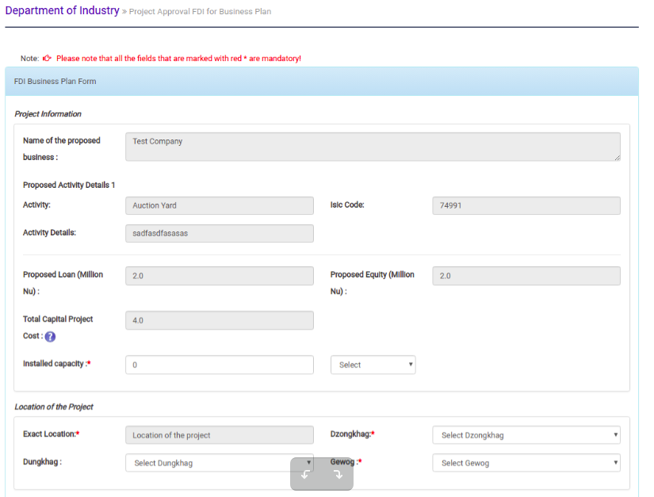

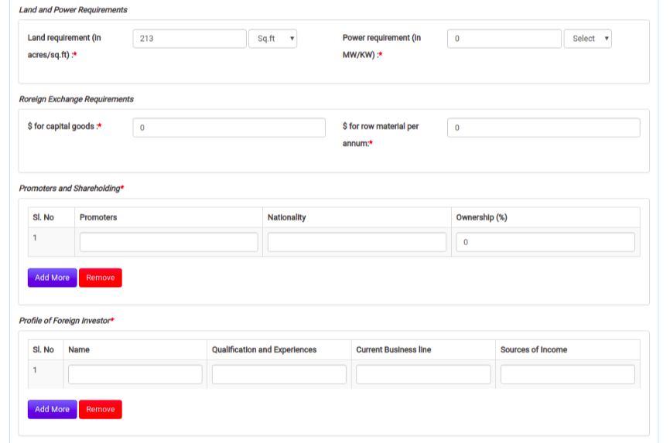

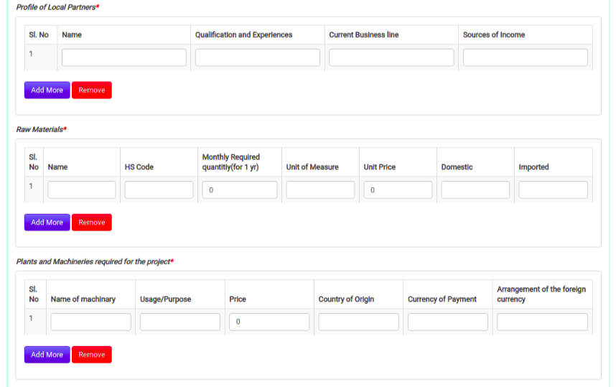

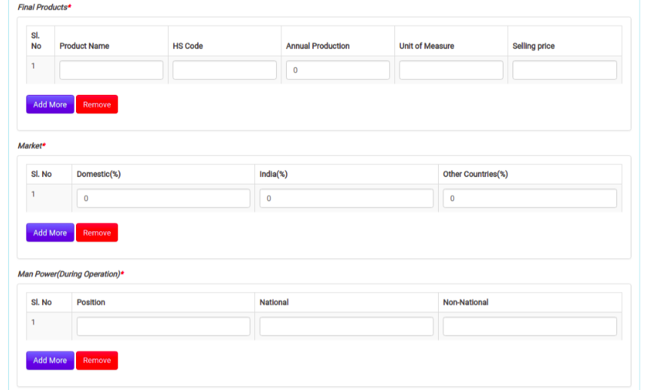

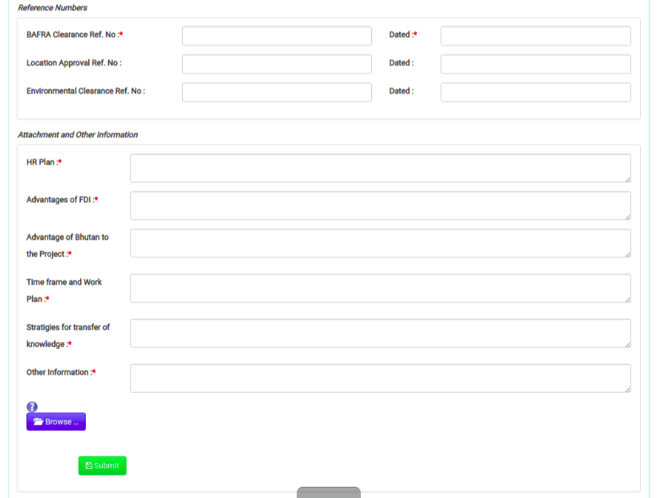

* After filling up the form with necessary fields, then the promoters will be redirected to following acknowledgement page. The application Id will remains same for FDI project registration applied before but with this application id, the business plan information will be added and need to verify and approve by the FDI focal person.



### Use-Case#4: Verification of FDI business plan application by Designated Person from FDI division, DOI

#### Brief Description

This Use-Case is all about how the FDI business plan is verified by the designated person from FDI.

#### Frequency

As mentioned earlier, the number of FDIRA applications is expected to be 15 to 20 per year.

#### Actor(s)

The acting member to perform this task will be the designated person from FDI.

#### Basic Flow of Events

* The designated person from FDI logs into the System and gets the task list.
* He/she verifies the details of the DFI Business plan submitted by promoters.
* Approve the DFI business plan if the details are up to mandates.

#### Alternative Flows

If the designated person from FDI finds that the FDI Business plan can be rejected then he/she can do that with proper reasons for rejecting the application and accordingly the promoters will be notified through email and sms.

#### Special Requirements

N.A.

#### Pre-conditions

The designated person from FDI needs to have valid Log-in Ids & Passwords to access the system.

#### Post-conditions

**Basic Flow**

* The applicant gets a notification for the FDI Business plan Approval.

#### Trigger

He/she starts performing the above mentioned tasks.

#### User Interface Presentation

* The designated person form DFI login to the system from the following link.



* He/she need to select application from group task and claim to my task by clicking on application number to verify the application. He/she can also release application back to group task by clicking on red cross image.



* Open the application from my task to verify and proceed further. The following form represent the application detail submitted by the promoters.

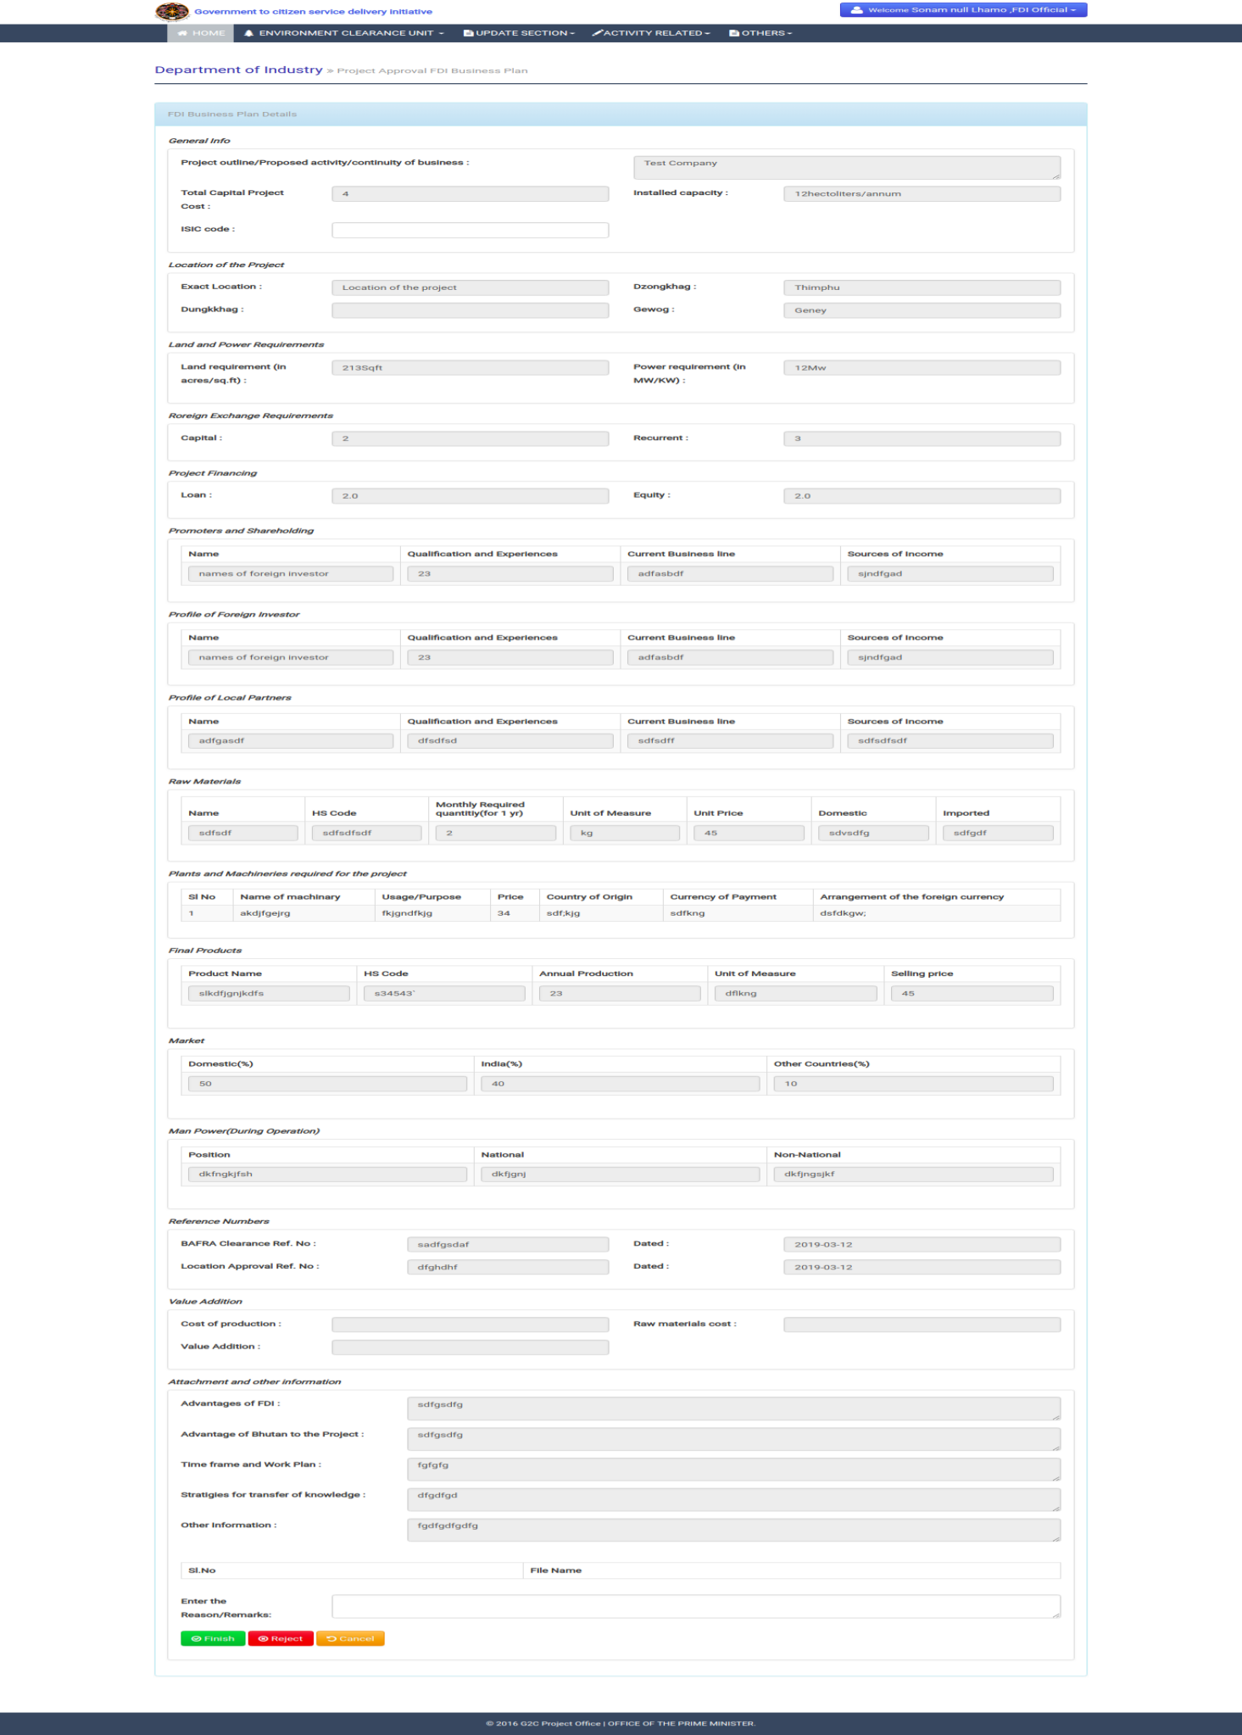

* After verifying the details submitted by the promoters, he/she need to print final business plan certificate and issue to the promoters for further license application.

## Process Flow for .

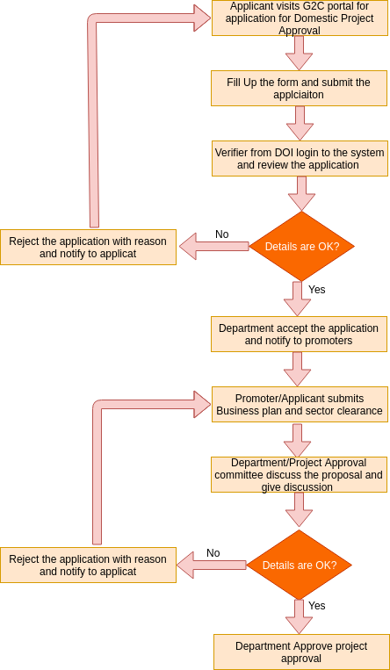

* The process flow shown above depicts the AS-IS and TO-BE scenario of Application for domestic Project Approval. It has mainly four use-cases that includes

1. Submission of Registration Application Form,
2. Verification of application and generation of certificate by designated person from DoI ,
3. Submission of Business plan.
4. Verification and approval of business plan.

* Functionality wise there will be the following parts:
* Apply for the **Application of Domestic Project Approval** under DOI will be made open to public where promoters/applicant can apply without having account created with system.
* Check the status of application- is exposed to the Common G2C Service Gateway without any log-in i.e. accessible to all.
* Verification of application and generation of FDI Registration Certificate by the designated person form DOI.
* Apply for the Business plan from same link **(Application of Domestic Project Approval)** which is open to pubic where promoters/applicant can apply at any time.
* Designated person from DOI can verify the business plan and generate final certificate.

### Transaction Volume

The estimated number of application for Project Approval for Medium and Large Industries per year is around 15 to 20.

### Use-Case# 1: Submission of Domestic Project Approval Application

#### Brief Description

This Use Case is how the promoter fills up the **Application for Domestic Project Approval** and submits the same to DoI focal person.

#### Frequency

As mentioned earlier, the number of applications is expected to be 15 to 20 per year.

#### Actor(s)

The actors for this use case are the Promoters who are applying for Project Approval.

#### Basic Flow of Events

* Applicant fills up the form
* Submits the from
* The Application status should be Waiting for Approval

#### Alternative Flows

N.A.

#### Special Requirements

N.A.

#### Pre-conditions

Applicant needs to have internet access and know the url to enter into the system.

#### Post-conditions

Designated person from DOI gets the submitted application in his/her task list.

#### Trigger

This process starts after clicking on the Application for Domestic Project Approval link from G2C portal under Industry Services.

#### User Interface Presentation

* Visit G2C portal to avail Application for Domestic Project Approval under Industry Services.

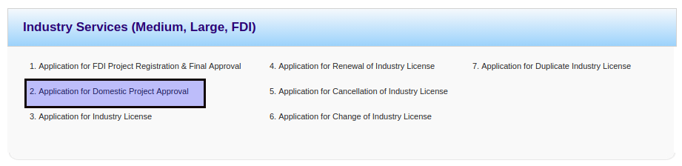

* Select service type as Domestic Registration application.

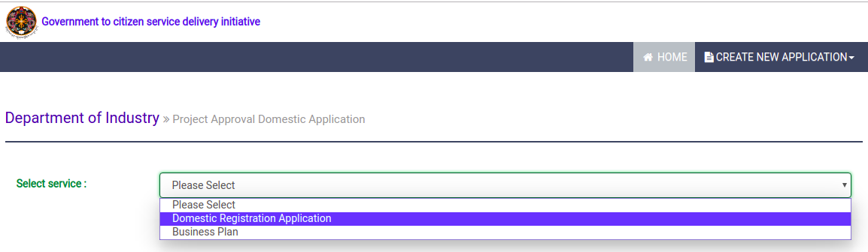

* Applicant need to select the service to which the project belongs to and ownership type of the project as shown below.

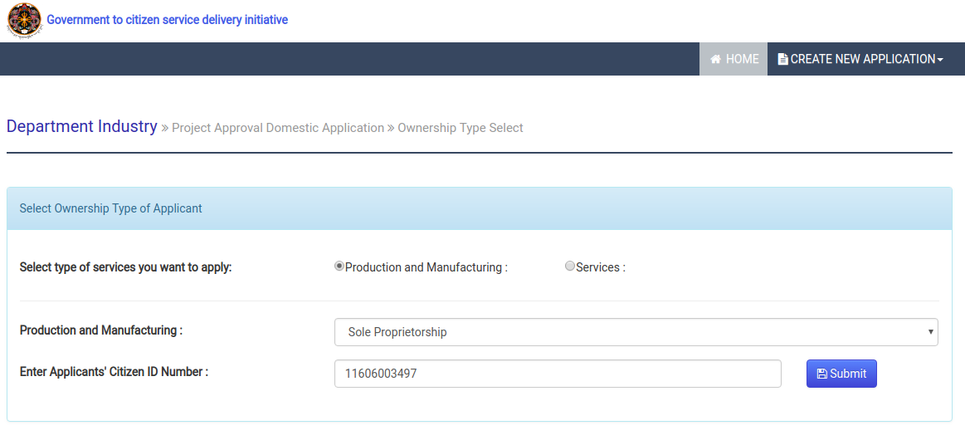

* The applicant will be redirected to the following form.

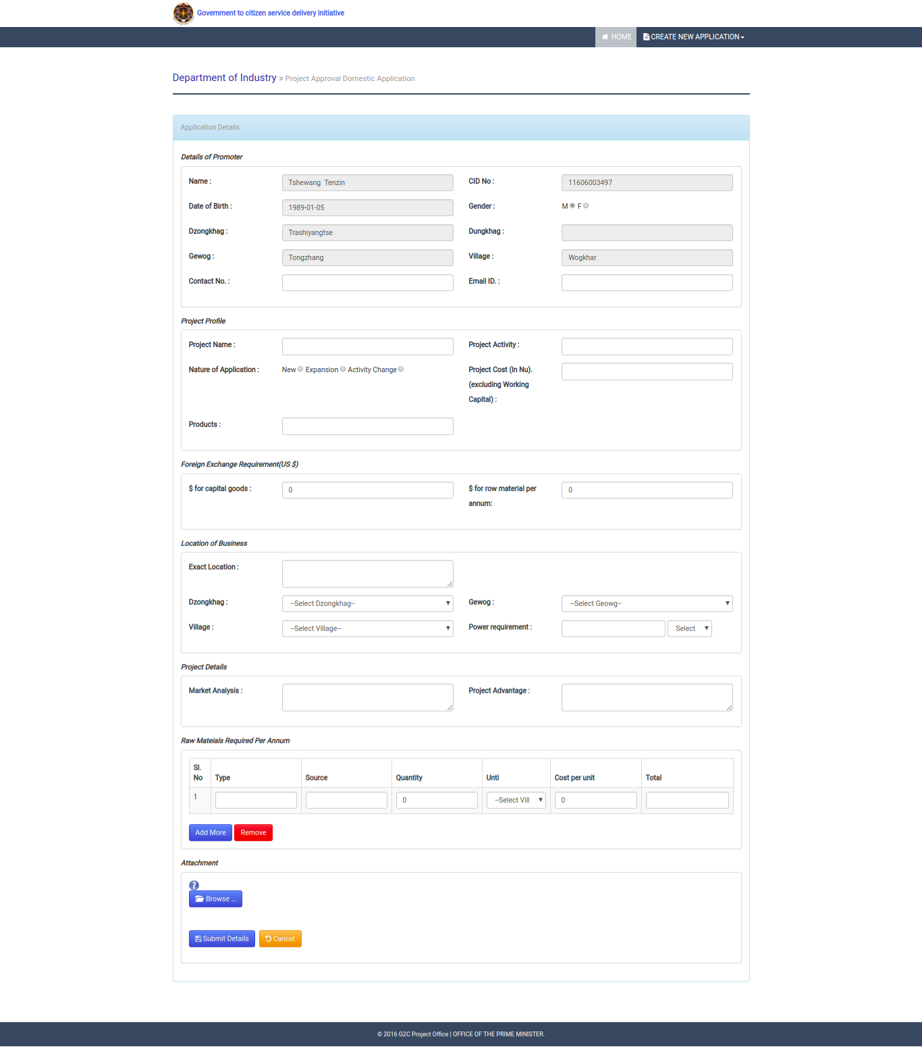

* After completing the form, the promoter can submit the form and will be redirected to following acknowledgement page

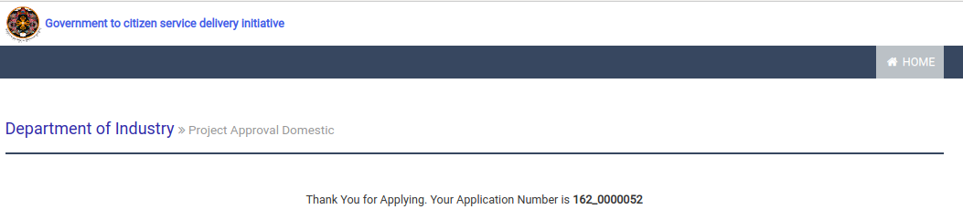

### Use-Case#2: Verification of application and generation of certificate by Designated Person from IID division, DOI

#### Brief Description

This Use-Case is all about how the Domestic application is verified by the designated person from IDD. Also it talks about how the certificate is generated after the application gets approved.

#### Frequency

As mentioned earlier, the number of Domestic applications is expected to be 15 to 20 per year.

#### Actor(s)

The acting member to perform this task will be the designated person from IDD.

#### Basic Flow of Events

* The designated person from IDD logs into the System and gets the task list.
* He/she verifies the details of the Application submitted.
* Approve the Application with proper remarks.

#### Alternative Flows

If the designated person from IDD finds that the Application can be rejected then he/she can do that with proper reasons for rejecting the application and accordingly the promoters will be notified through email and sms.

#### Special Requirements

N.A.

#### Pre-conditions

The designated person from IDD needs to have valid Log-in Ids & Passwords to access the system.

#### Post-conditions

**Basic Flow**

* The applicant gets a notification for the Application Approval.
* The designated person form IDD division takes a printed of the Certificates.
* Promotes collects the Certificate from IDD division (manual process).

#### Trigger

He/she starts performing the above mentioned tasks.

#### User Interface Presentation

* The designated person form IDD login to the system from the following link.



* He/she need to select application from group task and claim to my task by clicking on application number to verify the application. He/she can also release application back to group task by clicking on red cross image.



* Open the application from my task to verify and proceed further. The following form represent the application detail submitted by the promoters.

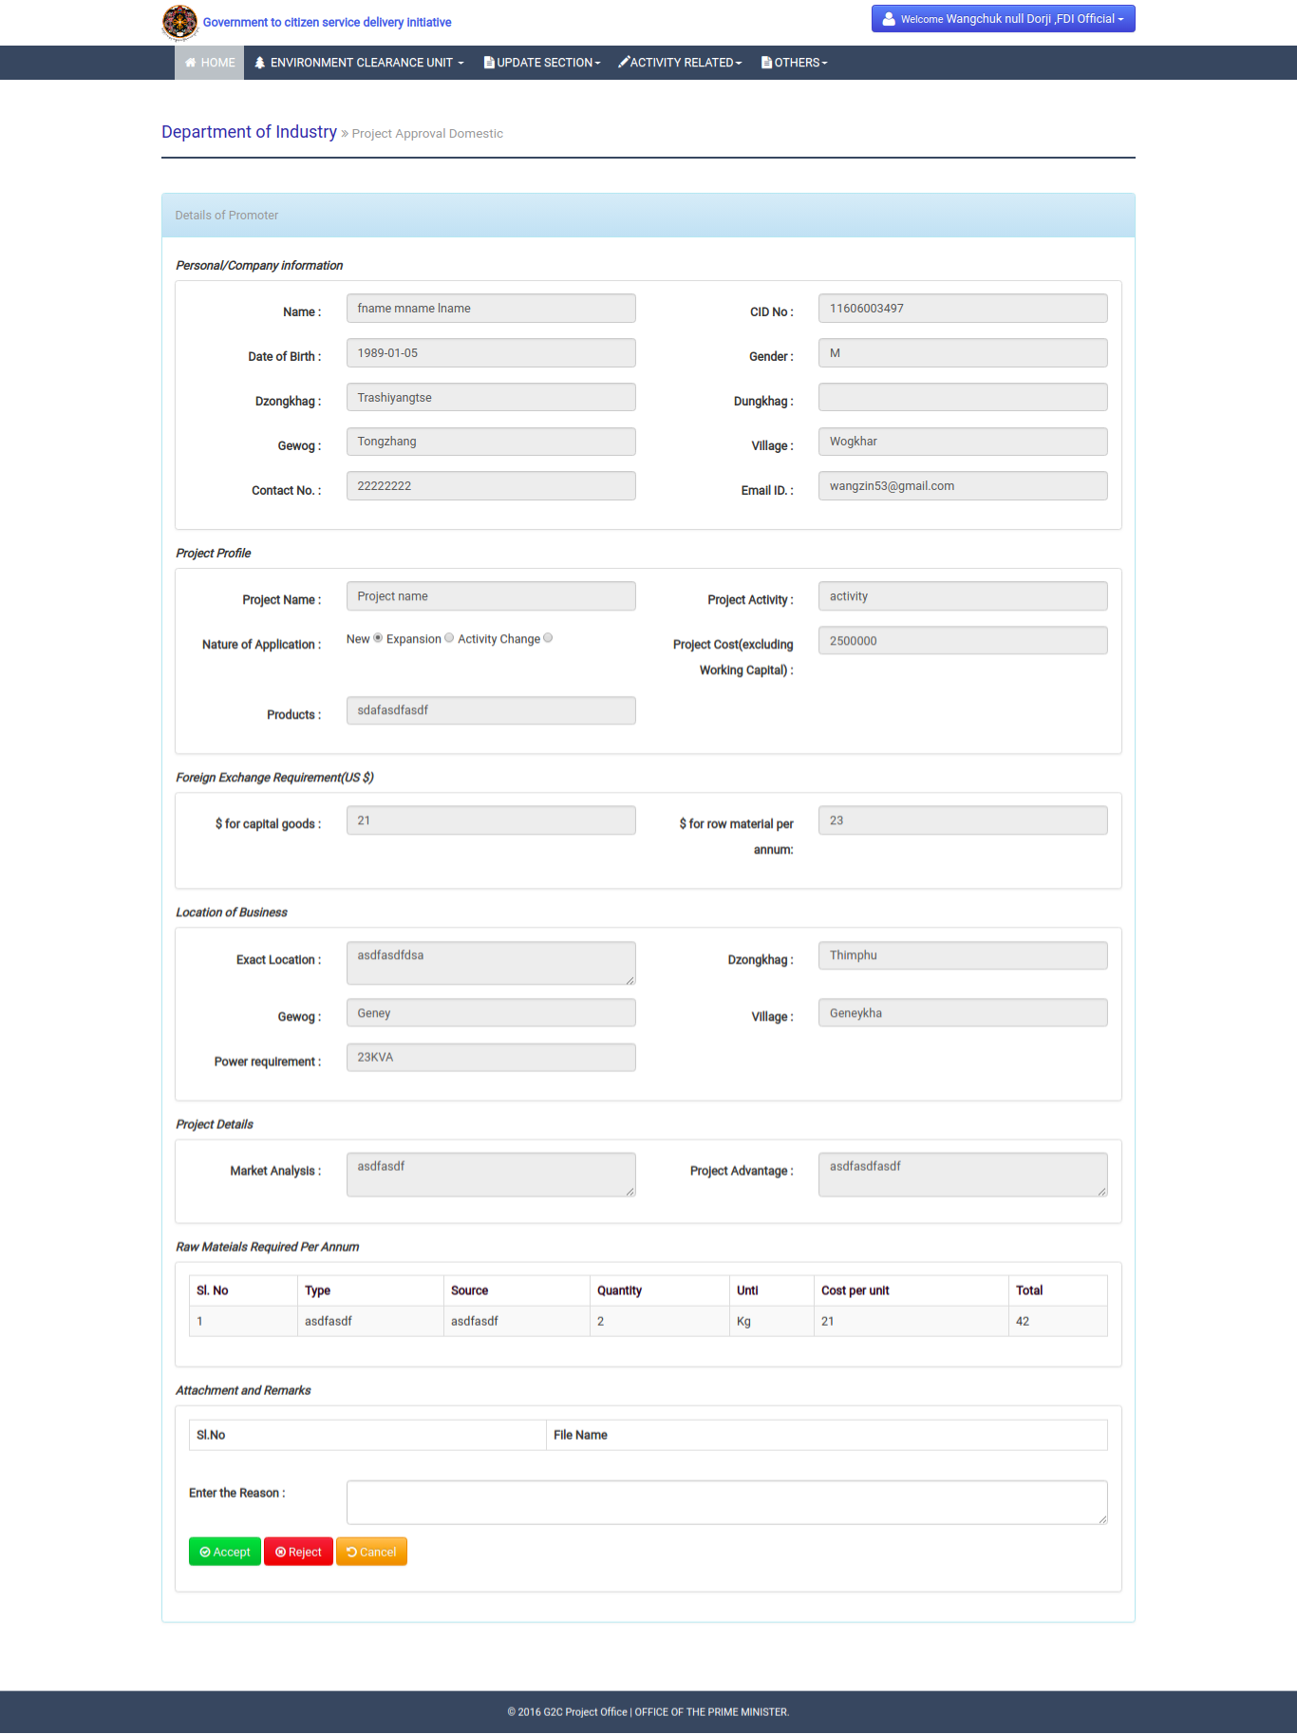

* After accepting the application, the promoters will get notified and need to proceed for business plan submission. Focal person will be redirected to the following acknowledgement page.

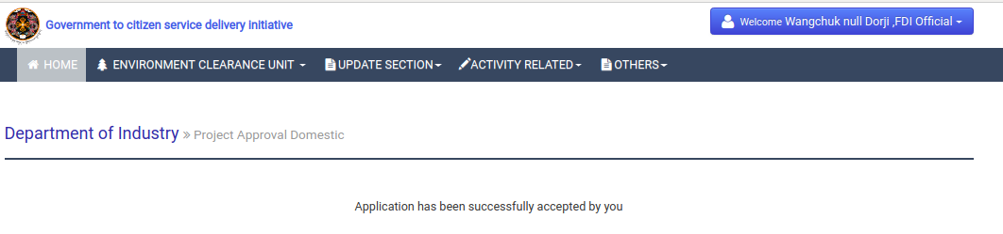

### Use-Case#3: Preparation of Business plan and submission of application for business plan.

#### Brief Description

This Use-Case is all about how the promoters prepare the business plan and submit the application.

#### Frequency

The number of Project Approval needed to be prepared is expected to be around 15 to 20.

#### Actor(s)

The acting member to perform this task will be the promoters /applicant.

#### Basic Flow of Events

* Applicant fills up the Business form.
* Submits the Business plan.
* The application will be there at approval task of designated person from IDD.

#### Alternative Flows

N.A.

#### Special Requirements

N.A.

#### Pre-conditions

Applicant needs to have internet access and know the application Id of Application for Domestic project approval.

#### Post-conditions

Designated person from IDD gets the submitted business plan applications in his/her task list.

#### Trigger

The process starts when the application for Domestic project is approved/accept by the designated person from IDD.

#### User Interface Presentation

* Visit G2C portal to avail Application for Domestic Project Approval under Industry Services.



* Select service type as Business approval.

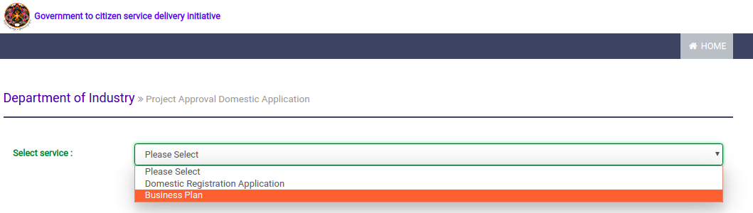

* Applicant needs to provide the application Id of FDI Registration from the following interface.

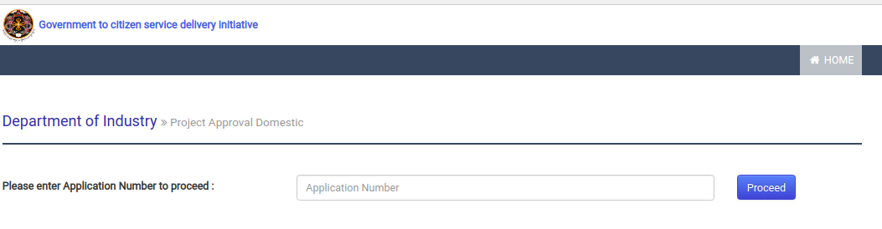

* After clicking on proceed button, if application id is valid and accepted, then the promoter will be redirected to following form for business plan.

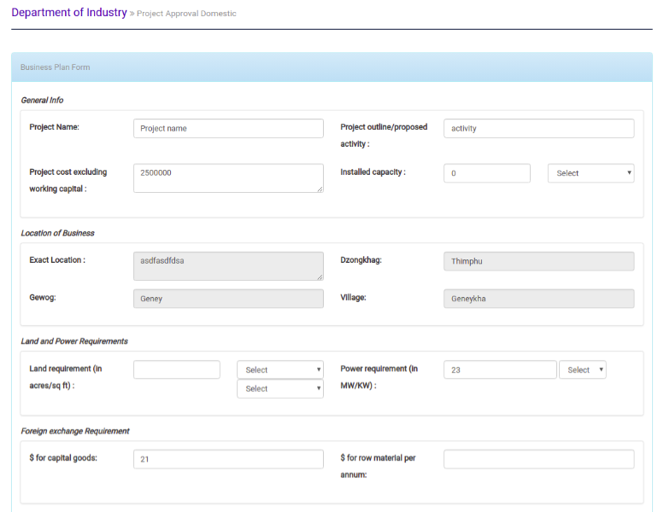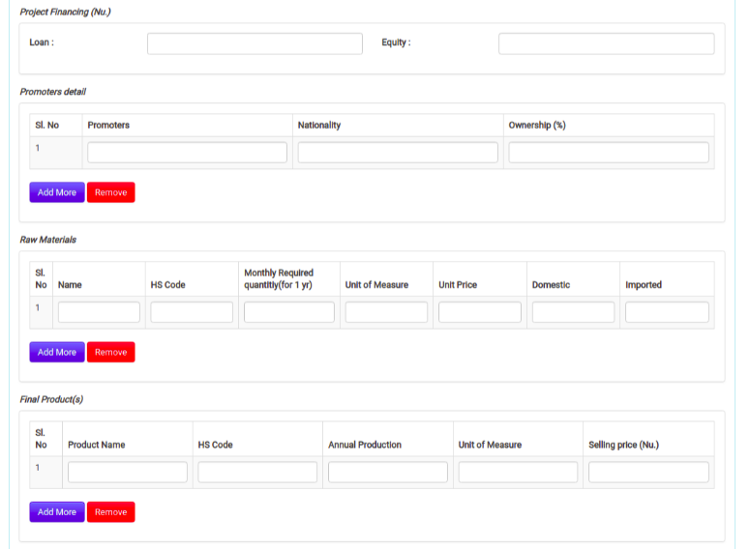

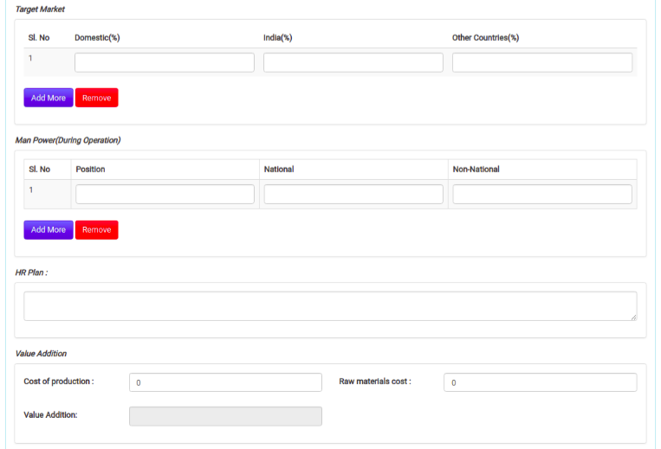

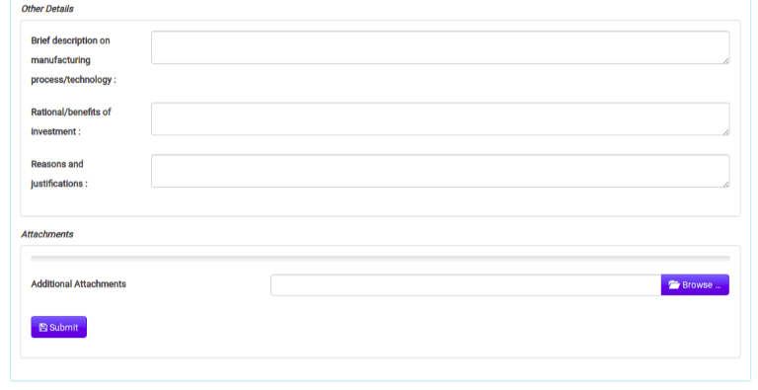

* After filling up the form with necessary fields, then the promoters will be redirected to following acknowledgement page. The application Id will remains same for Domestic project registration applied before but with this application id, the business plan information will be added and need to verify and approve by the focal person.

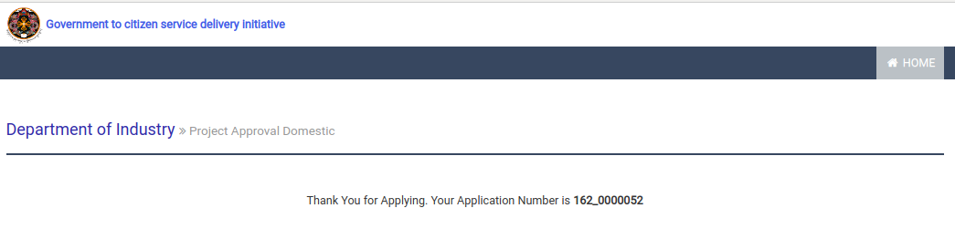

### Use-Case#4: Verification of business plan application by Designated Person from IDD division, DOI

#### Brief Description

This Use-Case is all about how the business plan is verified by the designated person from IDD.

#### Frequency

As mentioned earlier, the number of applications is expected to be 15 to 20 per year.

#### Actor(s)

The acting member to perform this task will be the designated person from IDD.

#### Basic Flow of Events

* The designated person from IDD logs into the System and gets the task list.
* He/she verifies the details of the Business plan submitted by promoters.
* Approve the business plan if the details are up to mandates.

#### Alternative Flows

If the designated person from IDD finds that the Business plan can be rejected then he/she can do that with proper reasons for rejecting the application and accordingly the promoters will be notified through email and sms.

#### Special Requirements

N.A.

#### Pre-conditions

The designated person from IDD needs to have valid Log-in Ids & Passwords to access the system.

#### Post-conditions

**Basic Flow**

* The applicant gets a notification for the Business plan Approval.

#### Trigger

He/she starts performing the above mentioned tasks.

#### User Interface Presentation

* The designated person form IDD login to the system from the following link.



* He/she need to select application from group task and claim to my task by clicking on application number to verify the application. He/she can also release application back to group task by clicking on red cross image.



* Open the application from my task to verify and proceed further. The following form represent the application detail submitted by the promoters.

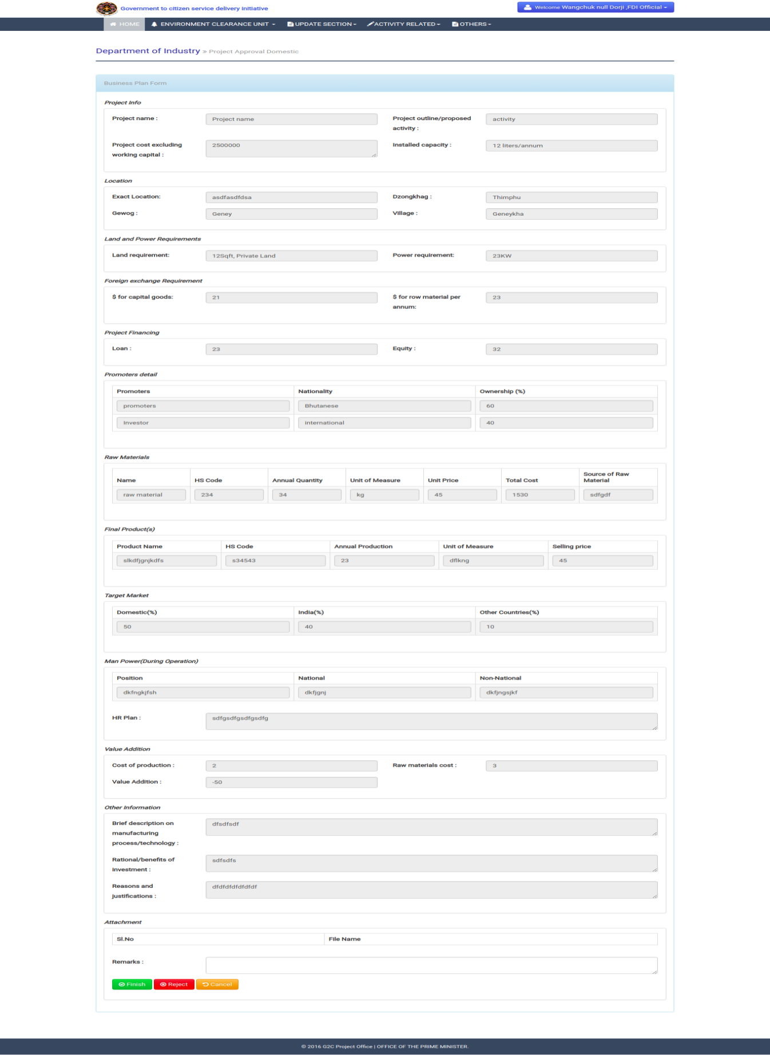

* After verifying the details submitted by the promoters, he/she need to print final business plan certificate and issue to the promoters for further license application.

Reports

## Report# 1: Detail Report for approved FDI Projects in a period

### Type of Report

Tabular

### Purpose

This is intended to track the accounts.

### Frequency

As and when required.

### Access Control/Security

Only Designated person from FDI can log into the system and generate the reports.

### Date Fields

|  |  |  |  |  |  |  |  |  |  |  |  |  |  |  |  |  |  |  |  |  |  |  |  |  |  |  |
| --- | --- | --- | --- | --- | --- | --- | --- | --- | --- | --- | --- | --- | --- | --- | --- | --- | --- | --- | --- | --- | --- | --- | --- | --- | --- | --- |
|  | | | |  |  |  |  |  |  |  |  |  |  |  |  |  |  |  |  |  |  |  |  |  |  |  |
|  |  |  |  |  |  |  |  |  |  |  |  |  |  |  |  |  |  |  |  |  |  |  |  |  |  |  |
|  |  |  |  |  |  |  |  |  |  |  |  |  |  |  |  |  | **Promoters** | | | | |  |  |  |  |  |
|  |  |  |  |  |  |  |  |  |  |  | **Project** |  |  |  |  |  |  |  |  |  |  |  |  |  |  |  |
|  |  | **Project** |  |  | **Date of** |  |  | **Project Cost** |  |  | **Activity** |  |  | **Foreign** |  |  | **Share** |  |  | **Local** |  |  | **Share** |  |  |  |
|  |  |  |  |  |  |  |  |  |  |  |  |  |  |  |  |  |  |  |
| **Sl.** |  | **Name** |  |  | **Approval** |  |  | **(Nu. Mm)** |  |  |  |  |  | **Investor** |  |  | **Holding** |  |  | **Investor** |  |  | **Holding** |  | **Status(Editable)** |  |

### Search criteria/Input Parameters

Selection of Day/Month/year